

Literature survey

* As we have experienced the COVID-19 pandemic lots of people got neither proper beds nor the treatment.
* In that situation home isolation was also demanded so , as we have experienced that pandemic and many people have lost their lives due to negligence.
* In treatment this project is mainly useful in situations like there is an emergency at that time this web site will be very useful.
* And mainly if a person is suffering from a serious illness and wants to get treatment in his preferred or liked or trusted hospital .
* This website is also useful to choose among the list of hospitals provided in our hospital database.
* And we have improved our website by giving the bed count number available in that hospital and the blood donations and also the required emergency blood banks also.
* This idea is completely created on our own and our team members have done a lot of effort in working on this website.
* Lack of information also may create a problem in life which may leads to death.



* For developing a web application, We’ve used brackets software. It is an open source software. We’ve designed it using HTML, CSS and BASICS OF JAVA SCRIPT.
* The Major functionalities of the project includes main functions:

1. Hospital bed availability
2. Blood availability
3. Plasma requirements

* The working of the web goes like:

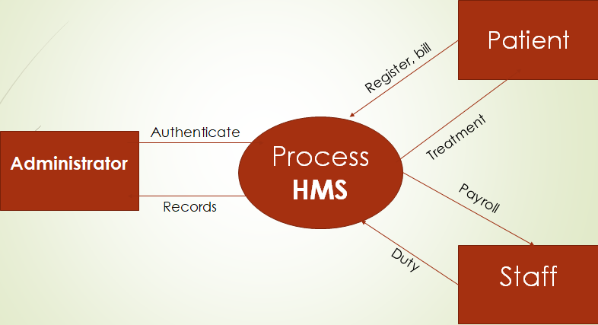

* A discrete data set is given where the information is given and the process goes on based on the requirement.
* We should overcome this limitations using the alternatives or also called as future enhancements.



* The enhancements we have are:

To obtain information and update the list with the requests

To cover up all the diagnosis.

* The project was a good experience for us. We think that from this project we learnt a lot about how an official website works.
* We faced many problems while working on this

1. Learn a different application like brackets from scratch.
2. Changing dependencies of brackets caused immense difficulty.

* From all the above matter I can summarize that importance of time bound and execution of work was realized. It gave us the experience to develop website like big official applications.
* The website is user friendly and can be run by any person with a mobile phone. The preparation of this project has helped a lot to learn the much unknown features and advantages of brackets and user interface
* References:

<https://www.researchgate.net/deref/http%3A%2F%2Fsearch.informit.com.au%2FdocumentSummary%3Bdn%3D445704802911875%3Bres%3DIELHEA>

* [The Complete 2022 Web Development BootcampUdemy](https://www.udemy.com/course/the-complete-web-development-bootcamp/learn/lecture/12287566?start=45)



* [How to Create Patient Record Management System – YouTube](https://www.youtube.com/watch?v=cMPbwuBbkks)
* [Hospital Management System software Video – YouTube](https://www.youtube.com/watch?v=ECwmWJNMrIU)
* [Hospitals | Must Watch | Purushotam Academy - YouTube](https://www.youtube.com/watch?v=D8g2_aFoyxc)

